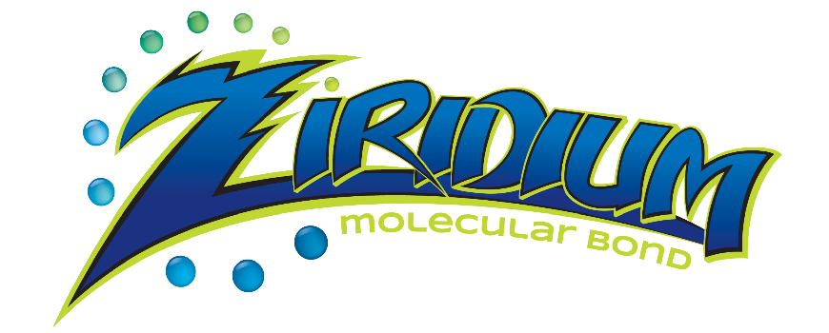

OUR story
Ziridium was founded with an industrialist spirit and a lofty objective: to offer consumers a premium product that was environmentally friendly coupled with world class customer service, while leading the way in the car care chemical market.
Every idea starts with a problem. From his early days in the auto industry, Danny recognized early on that solvent based paint protective coatings were compromising the environment. Danny had shadowed his grandfather, Tony Senior, and his father, Tony Junior, at Xzilon by Granitize for many years. At the time, Xzilon revolutionized the environmental protection segment. Initially developed as a protective coating for Boeing commercial aviation, it was then re formulated for the US auto market. The product was unique and different due to its solvent based characteristics.
This entrepreneurial spirit was passed down through the family to Danny, Tony Junior's youngest son. In 2010, the Federal Government passed a law that mandated automotive manufacturers to use waterborne paint systems to comply with the US Clean Air and Water Act, which was Danny's cue to act. Acquiring the tools of the trade from his father and grandfather, it was only natural that Danny set off on his own to develop a protective coating with zero VOCS specifically for automotive finishes that out-performed high solvent based products.
​After extensive research and product development, Ziridium was born. The first high performance protective coating that was eco-friendly launched over three years ago, and received glowing reviews. One specific trait that sets Ziridium apart from its competitors is its extensive 3rd party product testing. In the past, companies had refused to conduct testing in any form. Additionally, the vast majority of products in the industry was wax based, which simply does not last and easily bakes off a vehicle's finish in the heat. Ziridium is heat tested to 500 degrees and its longevity is proven to last on a finish with no re-application, making it a truly remarkable breakthrough product in the industry.

